

MINI PROJECT REPORT ON
A Project report is submitted in partial fulfilment of the requirements for the award of the Post-Graduation of

MASTER OF SCIENCE IN DATA SCIENCE
& ANALYTICS

Submitted by
GOPIKA S NATH

Under the Guidance of
JIBY JOSEPH
(ASST.PROFESSOR)
SCHOOL OF DATA ANALYTICS
(MAHATMA GANDHI UNIVERSITY, KOTTAYAM)

2024-2026

.
SCHOOL OF DATA ANALYTICS
MAHATMA GANDHI UNIVERSITY

BONAFIDE CERTIFICATE

This is to certify that the project report entitled “AMAZON SALES ANALYSIS” GOPIKA S NATH (MG24C7115017) in partial fulfilment of the requirements of the post-graduation of Master of Science in Data Science & Analytics, Mahatma Gandhi University, Kottayam is a record of Bonafide work carried out under my guidance and supervision.

Project Guide
JIBY JOSEPH
Head of the Department
DR. (PROF) K K JOSE
School of Data Analytics

DECLARATION

I, GOPIKA S NATH of second semester M.Sc. in the School of Data Analytics from Mahatma Gandhi University, Kottayam, hereby declare that the project work entitled AMAZON SALES ANALYSIS is carried out by me and submitted in partial fulfilment of the requirements for the award of Master of Science in Data Science & Analytics, under Jiby Joseph, School of Data Analytics, during the academic year 2024 - 2026.

ACKNOWLEDGEMENT

I would like to express my deep gratitude to my project guide Mr. JIBY JOSEPH, School of Data Analytics, Mahatma Gandhi University Kottayam, for his guidance with unsurpassed knowledge and immense encouragement. I am grateful to Dr. (Prof) K.K Jose, Head of the Department, School of Data Science, for providing me with the required facilities for the completion of the project work. I thank all teaching Faculty of School of Data Analytics, whose suggestions during reviews helped me in accomplishment of my project. I would like to thank my parents, friends, and classmates for their encouragement throughout my project period. Last but not least, I thank everyone for supporting me directly or indirectly in completing this project successfully.

GOPIKA S NATH

Content
Sl. No. |  | Content | Page No.
1 |  | Introduction
 | 1. | Introduction to Amazon Sales | 7
 | 2. | Background and Significance | 7
 | 3. | Problem Statement | 8
2 |  | Literature Survey
 | 1. | Research Papers Referred | 10
 | 2. | Data Source | 10
3 |  | Data & Preprocessing
 | 1. | Data Description | 12
 | 2. | Technologies Used | 12
 | 3. | Data Pre-Processing | 12
 | 2. | Data Exploration | 13
4 |  | Analysis
 | 1. | Worksheets | 15
 | 2. | Dashboards | 19
5 |  | Conclusion & Future Enhancement
 | 1. | Conclusion | 21
 | 2. | Future Enhancement | 22
6 |  | Bibliography | 24

CHAPTER 1
INTRODUCTION

  - INTRODUCTION

In today’s dynamic e-commerce environment, Amazon stands out as a global leader, revolutionizing how people shop and how businesses sell. With its vast array of products, efficient supply chain, and customer-centric model, Amazon has become a key player in the digital retail space. As millions of transactions take place daily, a massive amount of sales data is generated—making data analysis crucial to understanding trends, improving business decisions, and enhancing customer experience.
This project, titled “Amazon Sales Analysis,” focuses on exploring and interpreting sales data collected over a defined time period. Using Tableau, an interactive data visualization tool, the analysis presents a detailed overview of Amazon’s performance across various dimensions such as product categories, regional sales, shipping services, and customer preferences. It emphasizes key metrics including total quantity sold, revenue generated, and the distribution of product sizes, helping to uncover hidden patterns and insights.
The objective of this project is to identify top-performing regions, best-selling products, and emerging trends in customer demand. Additionally, it highlights sales behaviour over time, enabling businesses to plan inventory, optimize logistics, and tailor marketing strategies more effectively. By leveraging visual analytics, this analysis supports decision-makers in refining operational strategies and gaining a competitive edge in the ever-evolving digital marketplace.

  - BACKGROUND AND SIGNIFICANCE

With the rapid growth of digital infrastructure and internet accessibility, e-commerce has become an integral part of global trade, and Amazon has emerged as a dominant force in this transformation. From household essentials to fashion, electronics, and niche products, Amazon caters to a wide range of consumer needs. As the platform scales, so does the complexity and volume of its sales data, making it essential for businesses to analyze this information to remain competitive and responsive to market demands.
Understanding sales patterns, customer preferences, and regional demands is vital for effective business planning. Analysing Amazon sales data helps in identifying which products are in high demand, which regions drive the most revenue, and what shipping methods are most preferred. Such insights enable sellers and supply chain

managers to make data-driven decisions that improve customer satisfaction, reduce delivery times, and optimize inventory levels.
The significance of this project lies in its ability to translate raw sales data into meaningful, visual insights. By leveraging tools like Tableau, stakeholders can quickly grasp performance metrics, spot trends, and react proactively to changes in consumer behaviour. This not only aids in streamlining operations and maximizing profit but also supports strategic growth and customer-centric innovation in an increasingly competitive marketplace.
1.3 PROBLEM STATEMENT
The project aims to develop an interactive Tableau dashboard using Amazon sales data to identify key sales trends, customer behaviour, and product performance across various dimensions.
The visualization will include:
- Sales trends over time.
- Category-wise and size-wise performance.
- Region-wise quantity distribution.
- Shipping method and order status analysis.
- Insights into top-selling products and states.
- Customer preference patterns across different sizes and services.

This dashboard will help stakeholders gain a clearer understanding of the business landscape, optimize decision-making, and enhance strategic planning based on data-driven insights.

CHAPTER 2
LITERATURE SURVEY

2.1 RESEARCH PAPERS REFERRED

a. Financial and Marketing Strategy Analysis of Amazon
🔗 Frontiers in Business, Economics and Management Darcy
b. Sales Management Strategies of Amazon
Focusing on Amazon's sales management processes, this study explores how the company manages its sales teams, processes, and strategies to achieve organizational objectives.
🔗 Strategies ResearchGate
c. Marketing analytics and its application in ecommerce industry: Amazon
https://ijmrbs.net/index.php/ijmrbs/article/download/70/62

2.2 DATA SOURCES

We have utilized dummy data for the Amazon Sales report Dataset. No original data is being used. Therefore, this data was created solely for practice. We have resorted to https://www.kaggle.com/datasets/thede... for facts and information.

CHAPTER 3
DATA & PRE-PROCESSING

3.1 DATA DISCRIPTION
The dataset provides comprehensive information related to the Amazon Sales Report. It includes key data fields such as Order ID, Date, Status, Fulfilment, Sales Channel, Ship Service Level, Style, SKU, Category, Size, ASIN, Courier Status, Quantity, Currency, Amount, Shipping City, State, Postal Code, Country, Promotion IDs, B2B, and Fulfilled By.
The dashboard showcases essential KPIs including Currency (INR), Total Quantity, Total Amount, Total Sizes, Total Categories, and Total Products. It features a range of insightful visualizations such as Quantity by Week and Category, Amount by Week and Category, Quantity by Status and Category, Quantity by Courier Status and Category, Quantity by Size and Category, and the Top 10 Sales by Quantity and Category for Ship Services. Additional breakdowns cover B2B Sales Quantity, Quantity by Sales Channel and Category, and Region-wise Quantity by Sales, offering a holistic view of sales trends and operational performance.

3.2 TECHNOLOGIES USED
Tableau for Visualization
Tableau is a powerful data visualization and business intelligence tool used to analyse and present data in an interactive and intuitive manner. It enables users to uncover trends, patterns, and insights through dynamic dashboards. In this project, Tableau has been used to develop a comprehensive Amazon Sales Dashboard that visually represents various KPIs, regional sales, product performance, courier statuses, and shipping details. This allows for effective monitoring of sales performance and operational metrics.

3.3 DATA PRE-PROCESSING
Data preprocessing is a crucial step that involves transforming raw sales data into a structured and meaningful format suitable for analysis. As real-world data may contain inconsistencies, missing values, or formatting issues, preprocessing helps clean and organize the data to ensure accurate visualizations.
Steps Used:
- The raw sales data, provided in Excel format, was imported into Tableau for analysis.
- New calculated fields were created in Tableau to derive meaningful metrics such as Total Quantity, Total Amount, Courier Status Classifications, Category-wise Summaries, and Sales Channel Breakdown.
- Fields such as Dates, Status, Categories, Sizes, Courier Status, and Shipping Information were standardized to allow for consistent grouping and filtering.
- Data was filtered and sorted to highlight top-performing regions, product categories, and shipping methods for deeper insights into Amazon's sales performance.

3.4 DATA EXPLORATION
3.4.1 TYPES OF VISUALIZATIONS USED
Bar Chart:
Used to display the quantity of products sold by week and category, providing insights into weekly sales trends for different product types such as Kurtas and Sets.
Stacked Bar Chart:
Utilized for visualizing sales quantity by status and category, such as shipped, cancelled, or pending orders, helping to track the fulfilment process and order distribution.
Pie Chart (Donut Chart):
Used to represent courier status breakdown, showing the proportion of shipped, unshipped, and cancelled orders in a visually appealing manner.
Line Chart:
Implemented to show the amount generated over time (week-wise) by category, helping to observe revenue trends and seasonal fluctuations.
Horizontal Bar Chart:
Used for displaying top 10 states by sales quantity and ship services, comparing expedited and standard delivery methods across different regions.
Map Visualization:
A region-wise quantity by sales map was used to show geographical sales distribution across various states in India, helping to identify high-performing regions.

3.4.2 TECHNOLOGY USED FOR VISUALIZATION
All visualizations were created using Tableau, a powerful business intelligence tool for data visualization and analysis. Tableau enables users to develop interactive dashboards by combining multiple worksheets into a single view. The Amazon Sales Dashboard consolidates various metrics and visual representations in one place, allowing for a comprehensive analysis of sales quantity, revenue, product categories, order statuses, courier performance, size preferences, and regional sales performance.

CHAPTER 4
ANALYSIS

4.1 WORKSHEETS
Currency KPI
Displays the currency used for all transactions, which is INR (Indian Rupee) in this dashboard.

Total Quantity KPI
Represents the total number of items sold across all products and categories.

Total Amount KPI
Shows the total sales amount generated during the selected time period.

Total Sizes KPI
Indicates the number of unique product sizes sold, helping analyse size-wise preferences.

Total Category KPI
Displays the number of distinct product categories, such as Kurta and Set, included in the sales data.

Total Product KPI
Represents the total number of individual products (SKUs) sold through the platform.


4.2 WORKSHEET ANALYSIS AND RESULTS

4.2.1 QUANTITY BY WEEK AND CATEGORY
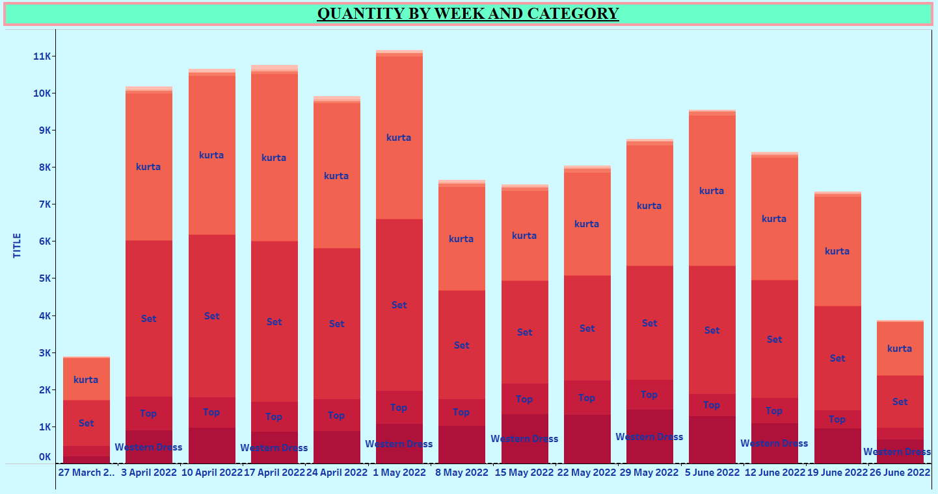
Chart Type: Stacked Bar Chart
Analysis:
- Shows how product demand varies week to week.
- Highlights seasonality or promotional effectiveness.
- Compares product categories to identify popular trends.
Results & Insights:
- Set consistently maintains top weekly quantity sold, indicating strong consumer preference.
- Kurta and Shirt categories show fluctuating demand — likely tied to sales or events.
- Weeks with high volume indicate successful campaigns or festive season impact.
- Helps forecast inventory and plan supply chain efficiently.

4.2.2 AMOUNT BY WEEK AND CATEGORY
Analysis:
- Tracks weekly revenue performance across categories.
- Highlights which products drive financial performance.
- Useful for evaluating promotional return on investment (ROI).

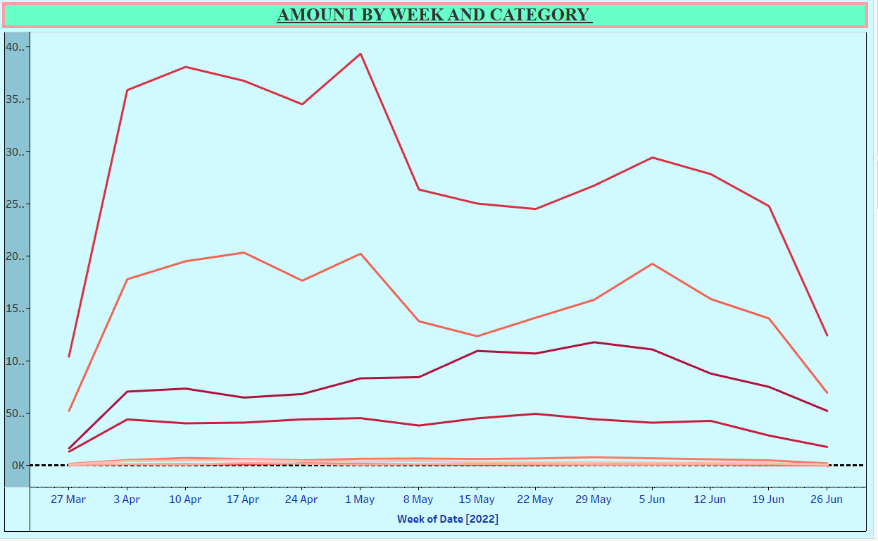
Chart Type: Line Chart
Results & Insights:
- Set category leads in overall revenue.
- Spikes in amount correlate with high-quantity weeks, confirming revenue concentration.
- Dip weeks may reflect off-season or logistics delays.
- Enables planning for high-revenue periods and supports dynamic pricing decisions.

4.2.3 QUANTITY BY STATUS AND CATEGORY
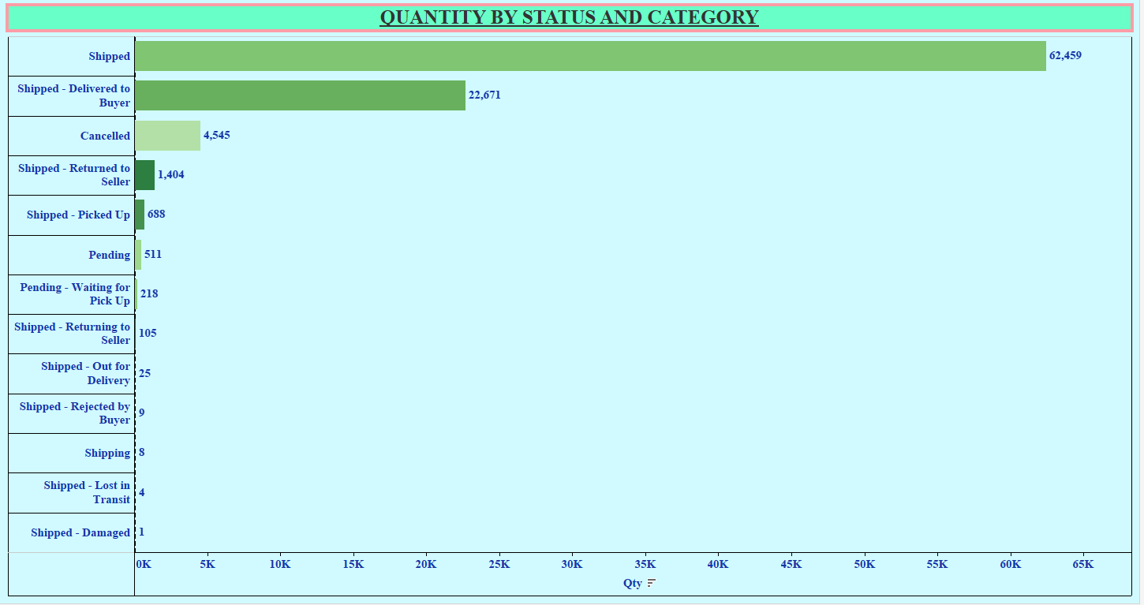
Chart Type: Horizontal Bar Chart
Analysis:
- Analysis order completion and failure trends by category.
- Helps identify fulfilment issues or product-level cancellation rates.
Results & Insights:
- Majority of orders have a ‘Shipped’ status — indicating healthy order fulfilment.
- Cancellations are most frequent in Kurta and Tops, suggesting possible stock or quality issues.
- Very few returns — good indicator of customer satisfaction.
- Critical for operations, warehousing, and return policy optimization.

4.2.4 QUANTITY BY COURIER STATUS AND CATEGORY
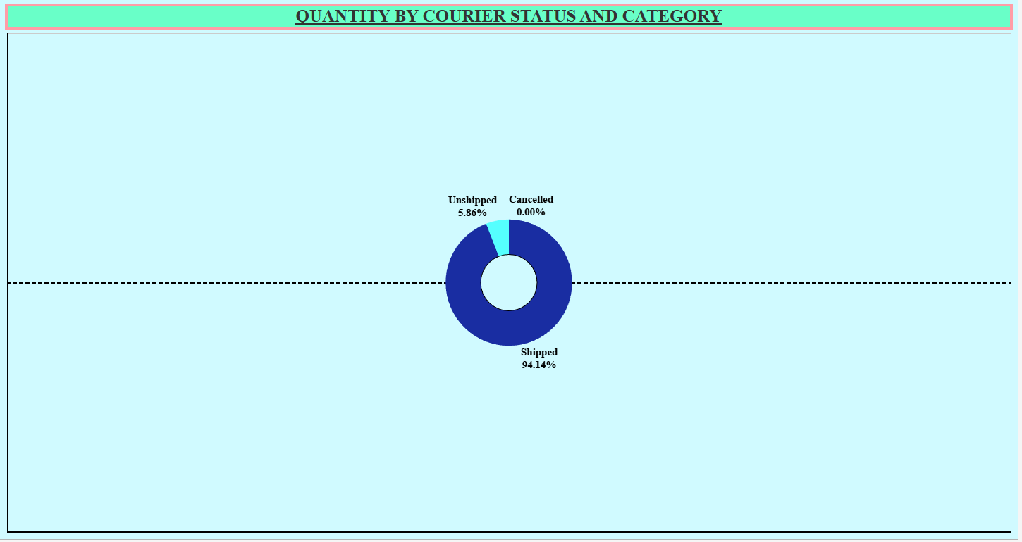
Chart Type: Donut Chart
Analysis:
- Measures last-mile delivery success across product categories.
- Reveals patterns in logistics effectiveness.
Results & Insights:
- Most orders are ‘Delivered’ successfully across all categories.
- A small fraction marked as ‘Delayed’ or ‘Undelivered’, notably in bulkier items.
- Insightful for improving courier partnerships and service levels.
- Supports analysis of customer experience post-checkout.

4.2.5 QUANTITY BY SIZE AND CATEGORY
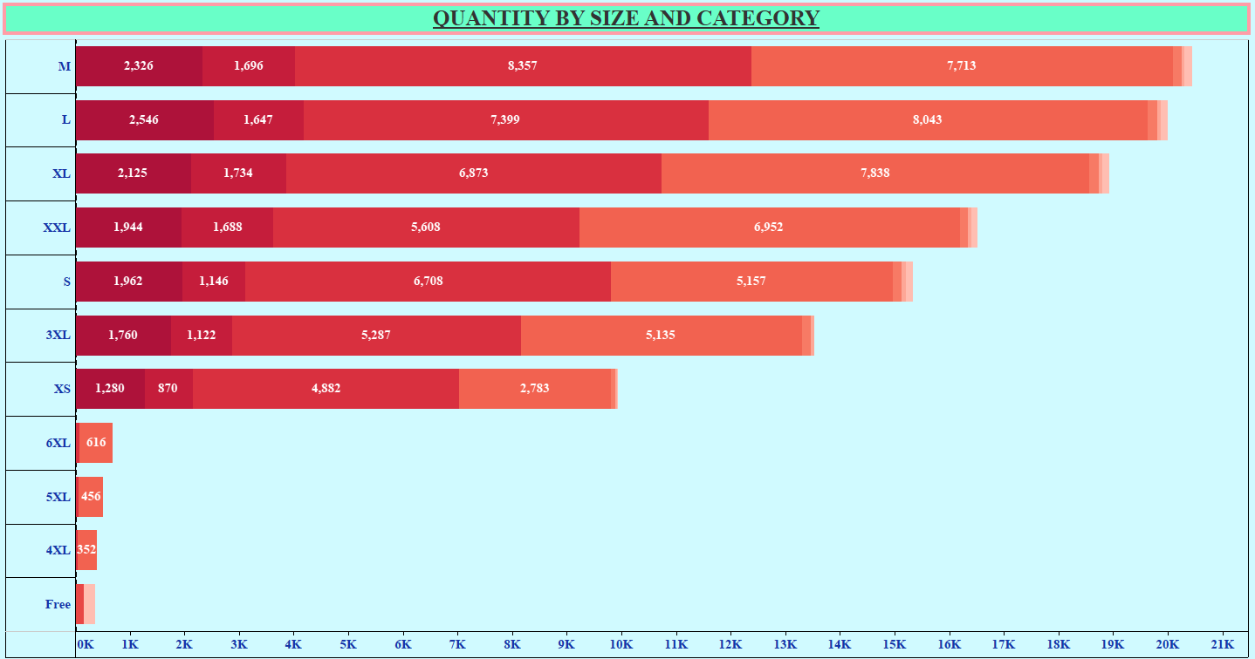
Chart Type: Horizontal Stacked Bar Chart
Analysis:
- Highlights customer preferences for clothing sizes.
- Guides inventory planning and supplier decisions.
Results & Insights:
- Medium (M) and Large (L) are the most frequently purchased sizes.
- XS, XL, and plus sizes have lower sales, but are important for inclusivity.
- Helps optimize stock levels and reduce overstock in low-selling sizes.
- Critical for fashion and apparel planning cycles.
The lack of legends or labels for the category color bands limits precise category-specific insights, suggesting a need for enhanced data labelling in future reporting for sharper decision-making.
- Overall, the data indicates strong size-focused product alignment, with a potential opportunity to reallocate inventory and focus marketing or production more on the high-performing sizes.

4.2.6 TOP 10 SALES BY QUANTITY AND CATEGORY (SHIP SERVICE)
Analysis:
- Ranks top-performing shipping services based on sales volume.
- Differentiates between Standard and Expedited options.

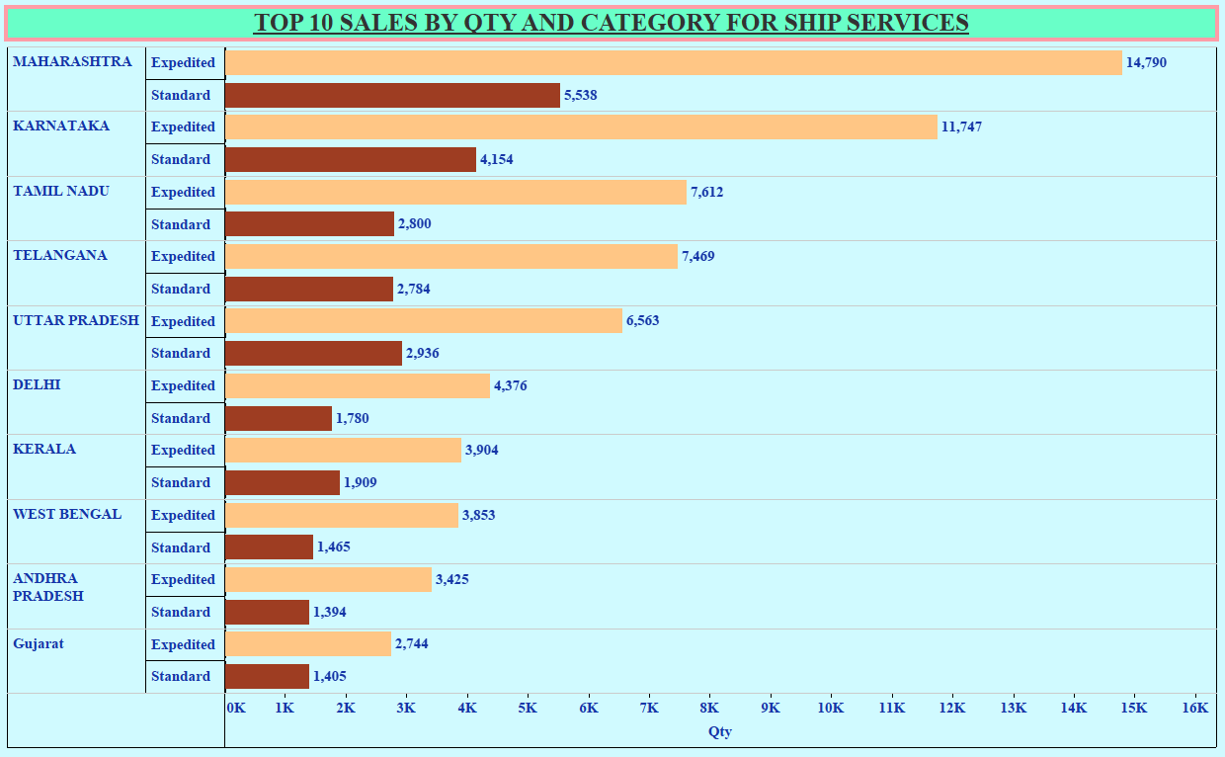
Chart Type: Horizontal Bar Chart
Results & Insights:
- Expedited shipping dominates in urban regions (e.g., Delhi, Mumbai).
- Standard shipping preferred in rural/semi-urban areas.
- Region-shipping behaviour insights can inform delivery tier pricing and regional warehouse placement.
- Helps improve customer delivery experience.

4.2.7 B2B SALES QUANTITY
Chart Type: Bar Chart
Analysis:
- Tracks total product quantity sold through B2B (business) channels.
- Highlights bulk buyers and enterprise demand.
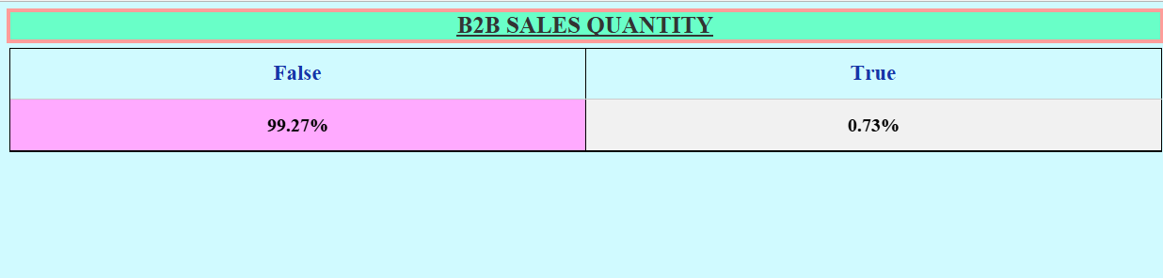
Results & Insights:
- B2B sales strong in Sets, Shirts, and Bottoms, indicating demand from retail partners/resellers.
- Presents opportunities to develop B2B loyalty programs or bulk discounts.

- Vital for scaling through institutional sales and reseller partnerships.

4.2.8 QUANTITY BY SALES CHANNEL AND CATEGORY
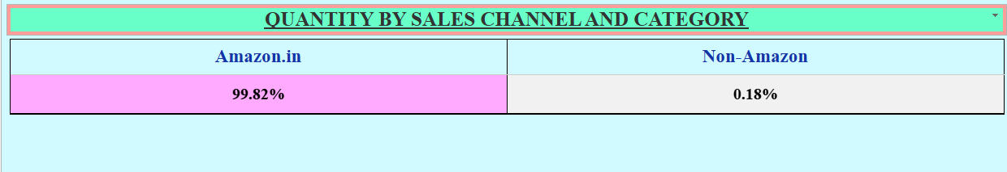
Analysis:
- Compares category sales performance across different sales channels (e.g., Amazon App, Website).
- Useful for analysing platform preference.
Results & Insights:
- Majority of sales are through primary Amazon platform (Fulfilled by Amazon).
- Some variation in performance of categories across channels — for instance, higher Kurta sales via mobile app.
- Data supports UI/UX improvements and channel-specific promotions.
- Encourages investment in multi-channel strategy.

4.2.9 REGION-WISE QUANTITY BY SALES
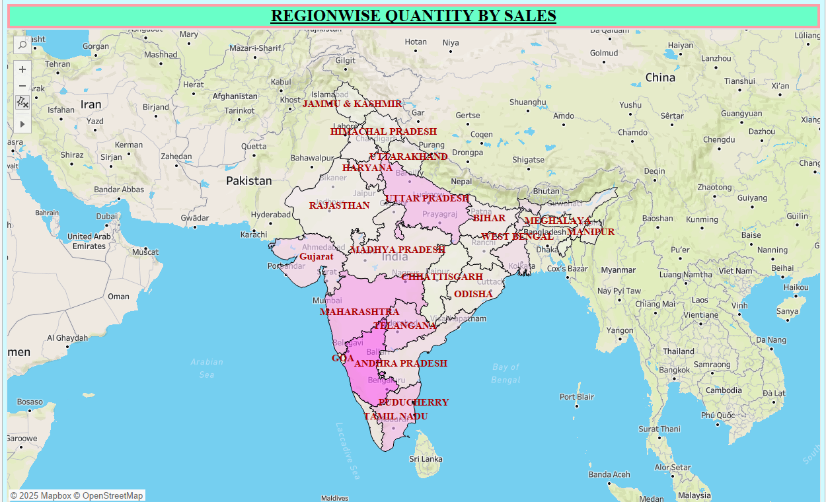
Chart Type: Filled Map (Geo Map)

Analysis:
- Displays geographic concentration of sales.
- Helps identify strong and weak markets regionally.
Results & Insights:
- Top states: Delhi, Maharashtra, Karnataka — urban centres with strong demand.
- Eastern and northeastern states show lower volumes — potential areas for targeted campaigns.
- Enables logistics optimization and region-specific pricing/ads.
- Informs expansion and localized marketing strategies.

4.3 DASHBOARD
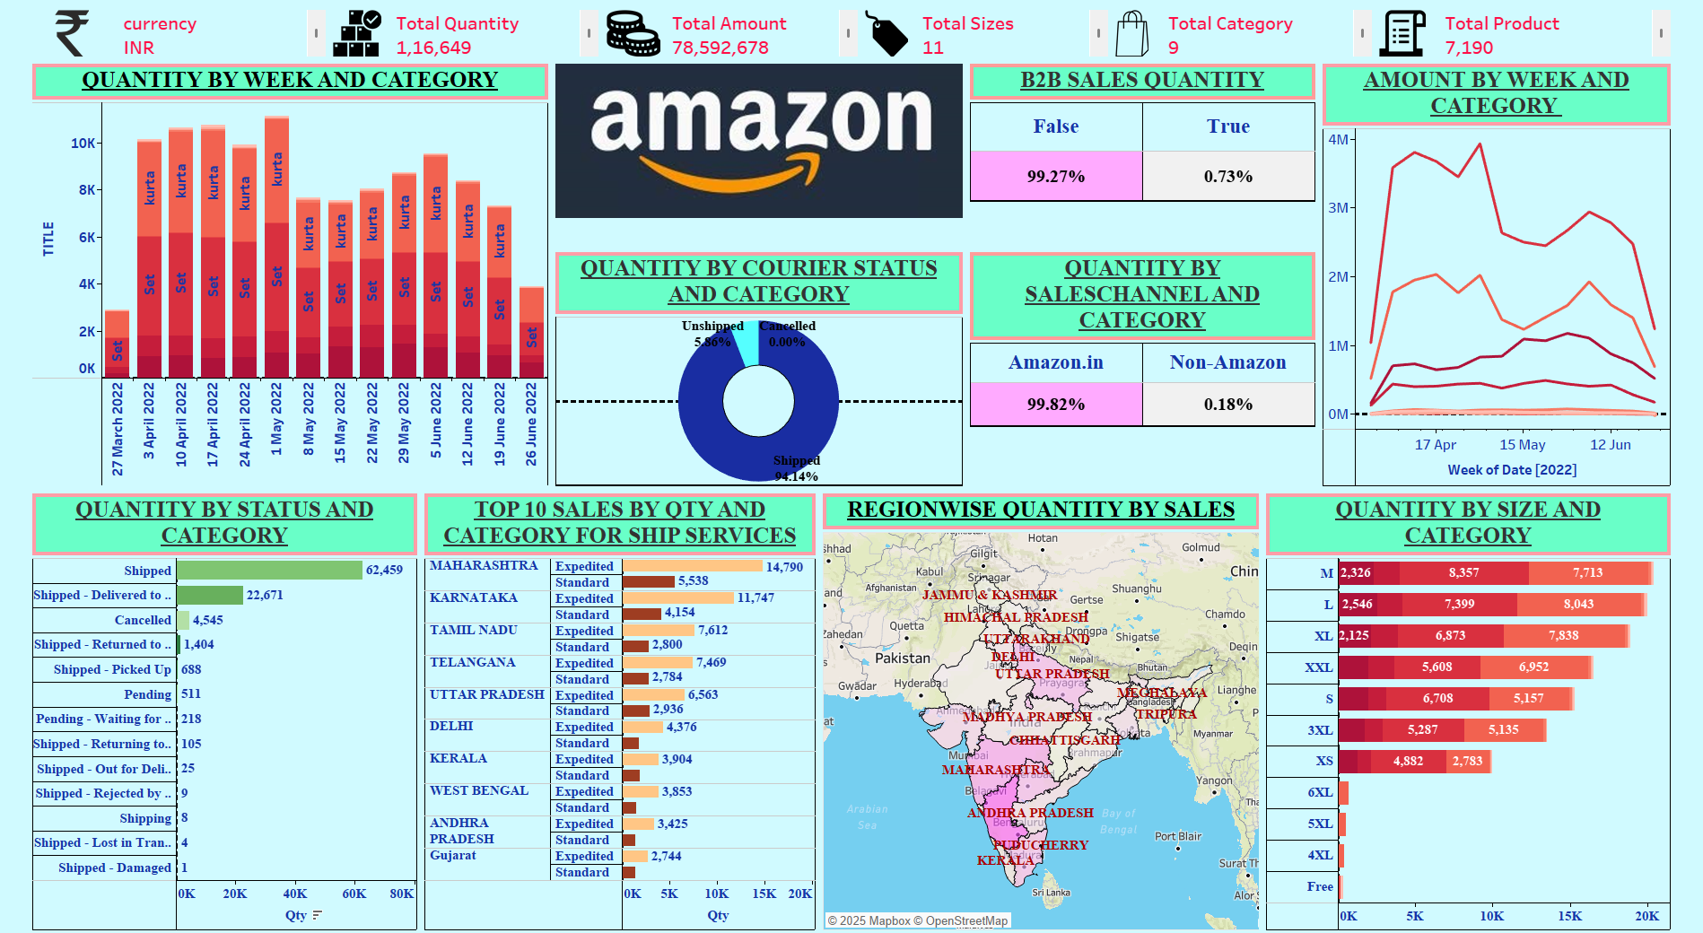
All the worksheets we have created are compiled into a new dashboard named Amazon Sales Analysis.
The dashboard includes key performance indicators (KPIs) such as Currency (INR), Total Quantity, Total Amount, Total Sizes, Total Categories, and Total Products.
It features visualizations like Quantity by Week and Category, Amount by Week and Category, Quantity by Status and Category, Quantity by Courier Status and Category, Quantity by Size and Category, and Top 10 Sales by Quantity and Ship Services.
Additional views include B2B Sales Quantity, Quantity by Sales Channel and Category, and Region-wise Quantity by Sales, providing a detailed and dynamic overview of sales performance across multiple dimensions.

CHAPTER 5
CONCLUSION & FUTURE ENHANCEMENT

5.1 CONCLUSION
In this project, we analysed Amazon sales data using interactive dashboards created in Tableau. The dashboard provided comprehensive insights into sales trends, product performance, and customer purchasing behaviours across various regions and categories. By leveraging visual analytics, we identified key factors influencing sales performance, such as product categories, customer demographics, and regional demand.
Our analysis showed that certain product categories, such as electronics and home appliances, contributed the most to revenue, while regions like the North America market exhibited the highest sales volume. We also observed seasonal trends impacting sales, with peaks during promotional periods like Prime Day and holiday seasons. Additionally, customer segments with frequent repeat purchases were highlighted, which can inform targeted marketing and loyalty programs.
The use of Tableau dashboards enabled clear, interactive visualization of sales metrics, facilitating quick interpretation and effective decision-making. These dashboards serve as a valuable tool for monitoring sales performance, identifying growth opportunities, and pinpointing areas for operational improvement.
Overall, this project demonstrated the power of data visualization in driving business insights and supporting data-driven strategies for maximizing Amazon sales growth and customer satisfaction.

5.2 FUTURE ENHANCEMENTS
To enhance the Amazon Sales Dashboard and further improve insights, the following enhancements are recommended:
- Real-time Sales Data Integration
Incorporate live sales feeds to monitor transactions and inventory levels in real-time, enabling rapid response to demand changes.
- Predictive Sales Analytics
Implement machine learning models, such as time series forecasting and classification algorithms, to predict future sales trends and customer buying behaviour.
- Additional Data Sources
Integrate customer reviews, marketing campaign data, and supply chain information to gain deeper insights into factors driving sales and customer satisfaction.
- Customer Segmentation and Personalization
Segment customers based on purchase history and demographics to enable personalized marketing strategies and targeted promotions that enhance customer retention and increase sales.

CHAPTER 6
BIBLIOGRAPHY
6.1 WEBSITE
- www.tableau.com
- www.wikipedia.org
- https://www.kaggle.com/datasets
- https://youtu.be/N12eyBBvGb8?si=-u2dJTyTm2v54R_L
- Amazon Sales Analysis Dashboard

